SPRINT SARI 2024 - Monthly report - June

2024-07-01

Table of Contents

Overall cohort 1

Stratified by pathogen type 4

This report covers the period from 1st June 2024 to 30th June 2024.

# Overall cohort

During the study period (1st June 2024 to 30th June 2024), there were **180** SARI patients admitted to the a participating SPRINT-SARI ICU. The cumulative number of patients in the SPRINT-SARI recorded for the year 2024 (1st January to 30th June) is now **1182**. The weekly number of SARI admissions aggregated by calendar month is shown in **Figure 1**. Baseline characteristics of these patients are summarised in the **Table 1**.

|  |
| --- |
| **Figure 1.** Weekly SARI admissions |
|  |

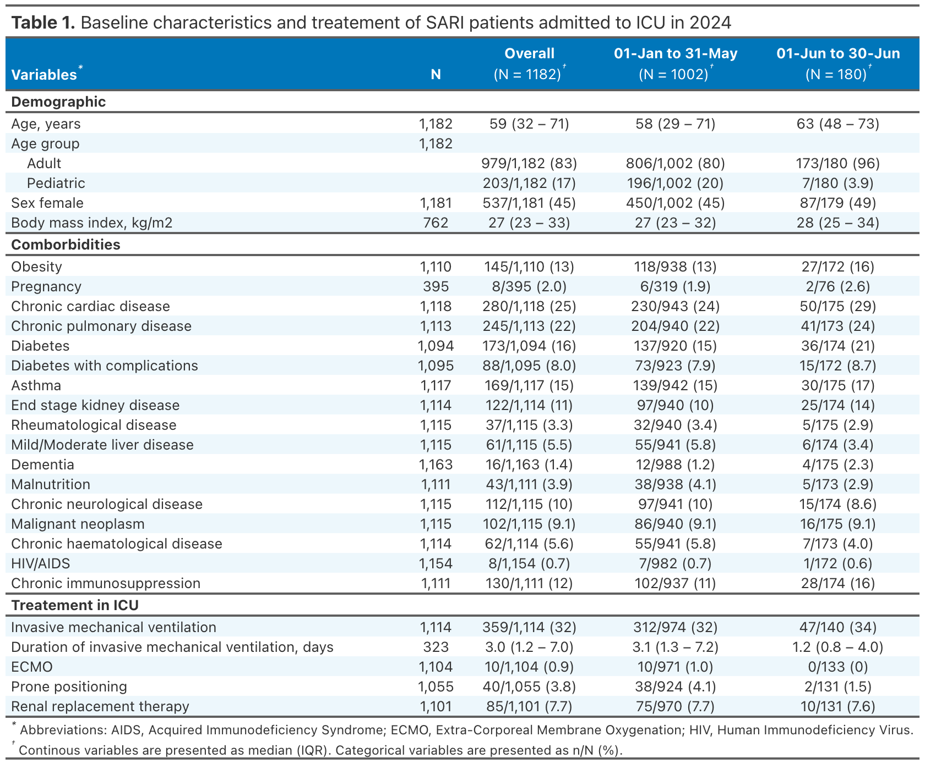

During the current study period 9/180 (5%) patients died in hospital, 89/180 (49%) were discharged to wards and 66/180 (37%) were still in hospital. The leading cause of death was treatment withdrawal 6/11 (55%). The median length of stay in ICU and in hospital was 3 (2-4) and 6 (4-10) days, respectively. The outcomes of these patients are summarised in the **Table 2**.

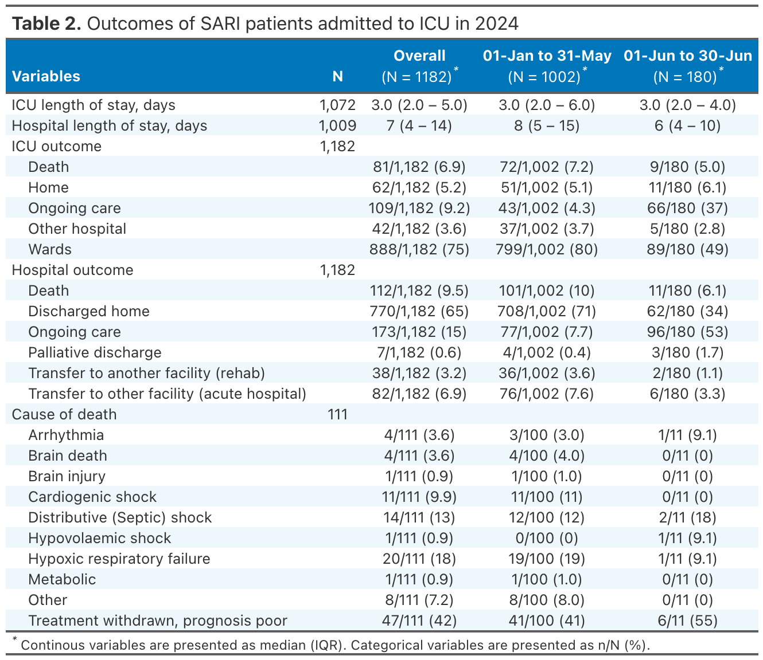

# Stratified by pathogen type

Overall, 32 patients presented a viral co-infection. Categorization was performed as follows: COVID-19 > Influenza > RSV > Other. Baseline characteristics, intervention, and outcomes according to the pathogen type are presented in **Table 3** and **Table 4**. Weekly SARI admissions according to the pathogen type are displayed in **Figure 2**. A heatmap summarising all co-infections is displayed in **Figure 3.**

|  |
| --- |
| **Figure 2.** Weekly SARI admissions according to the pathogen type |
|  |

|  |
| --- |
| **Figure 3.** Heatmap of patients with viral co-infections |
|  |
| Each row represents a patient. Dark blue cells indicate a positive infection. |

